Testing Documentation

1. Log into app as an admin

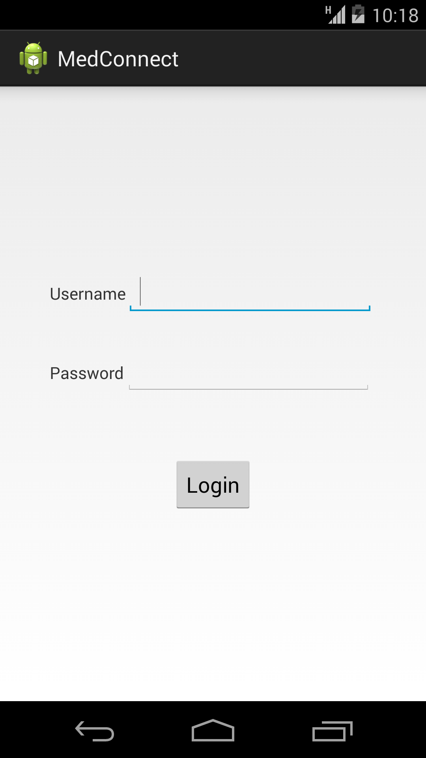

* 1. Navigate to doctors tab

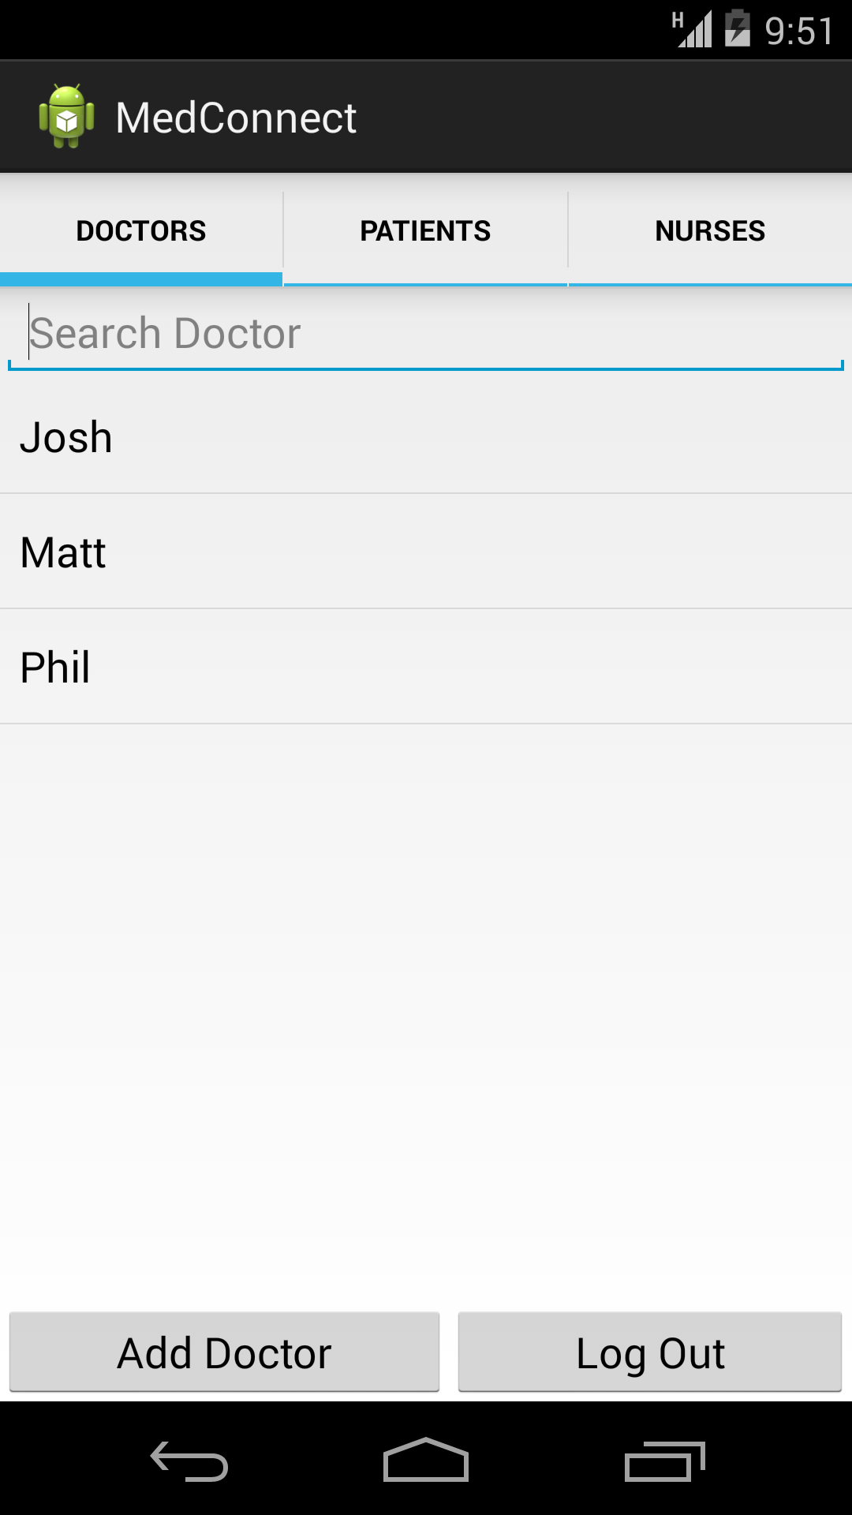

* 1. i) Attempt to create a new doctor user

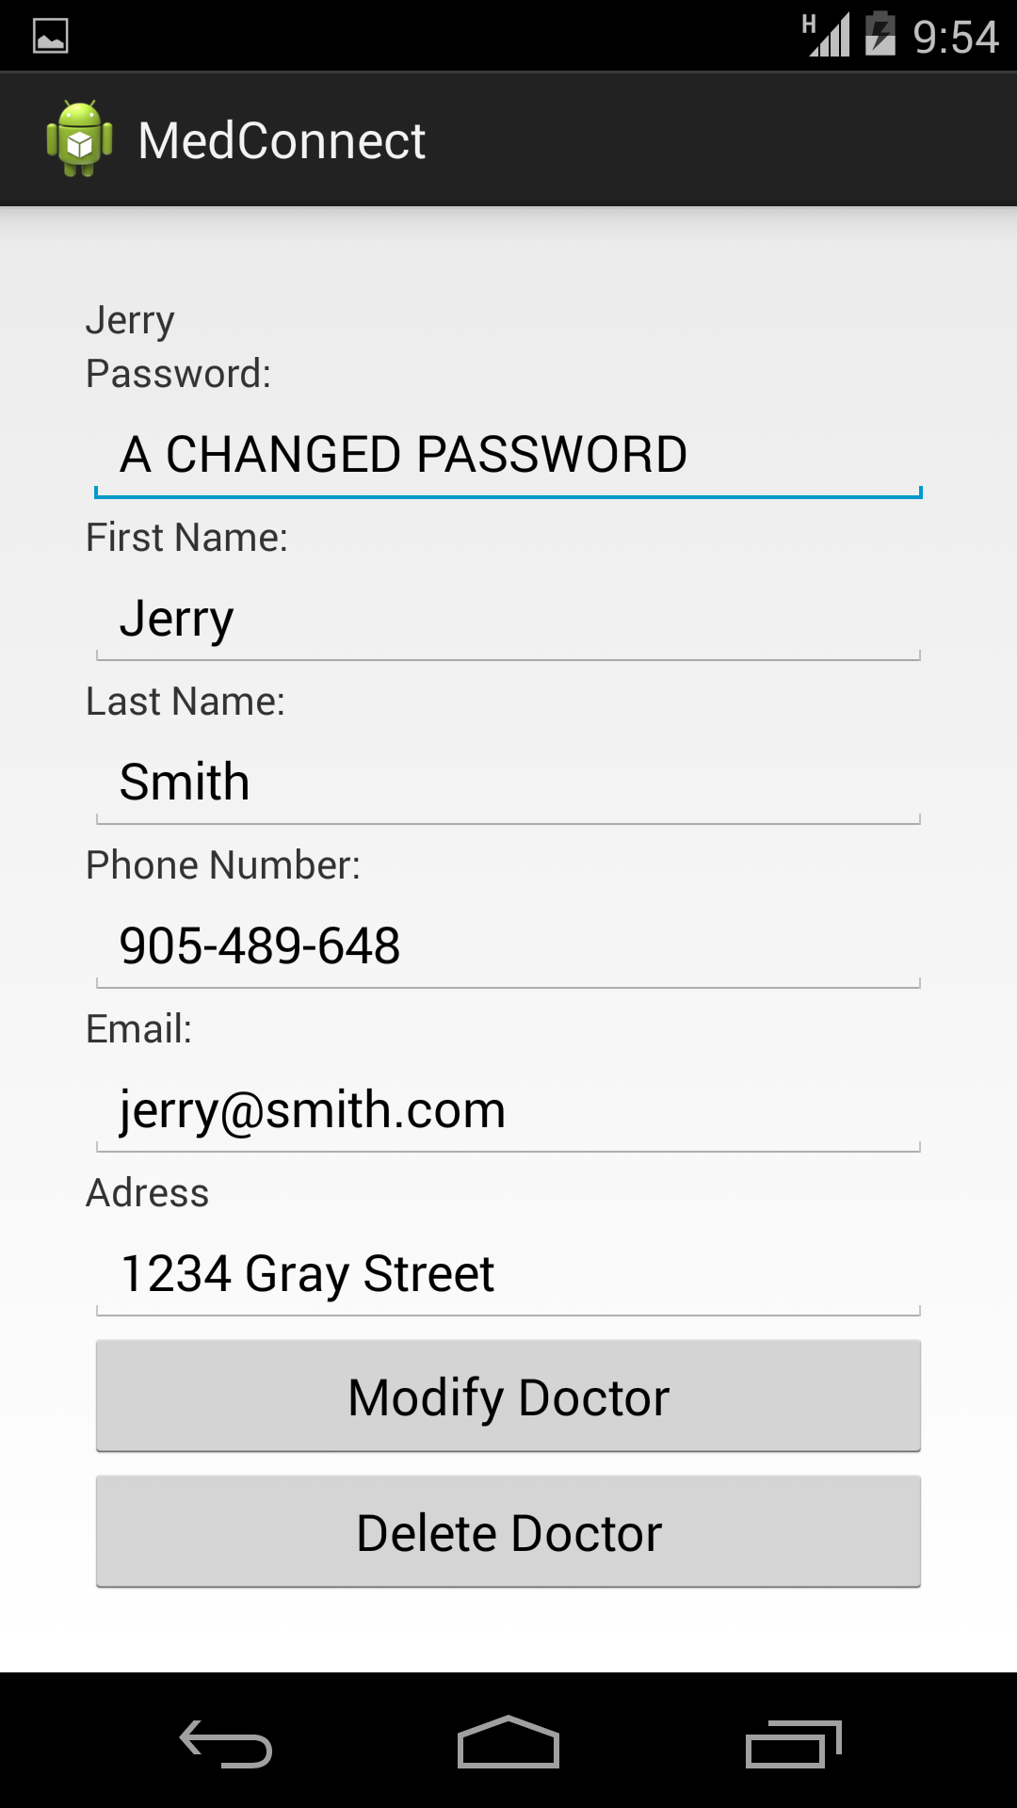

ii) Attempt to create a new doctor passed. New doctor is created.

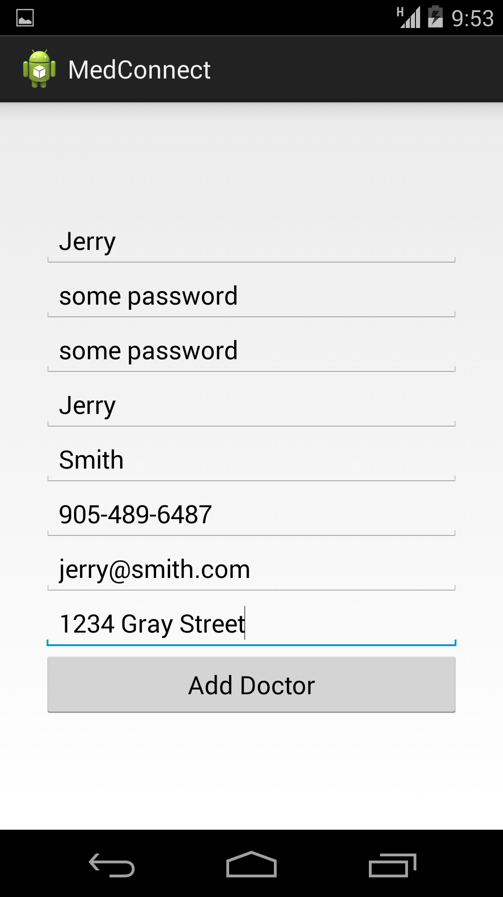

* 1. Navigate to nurse tab

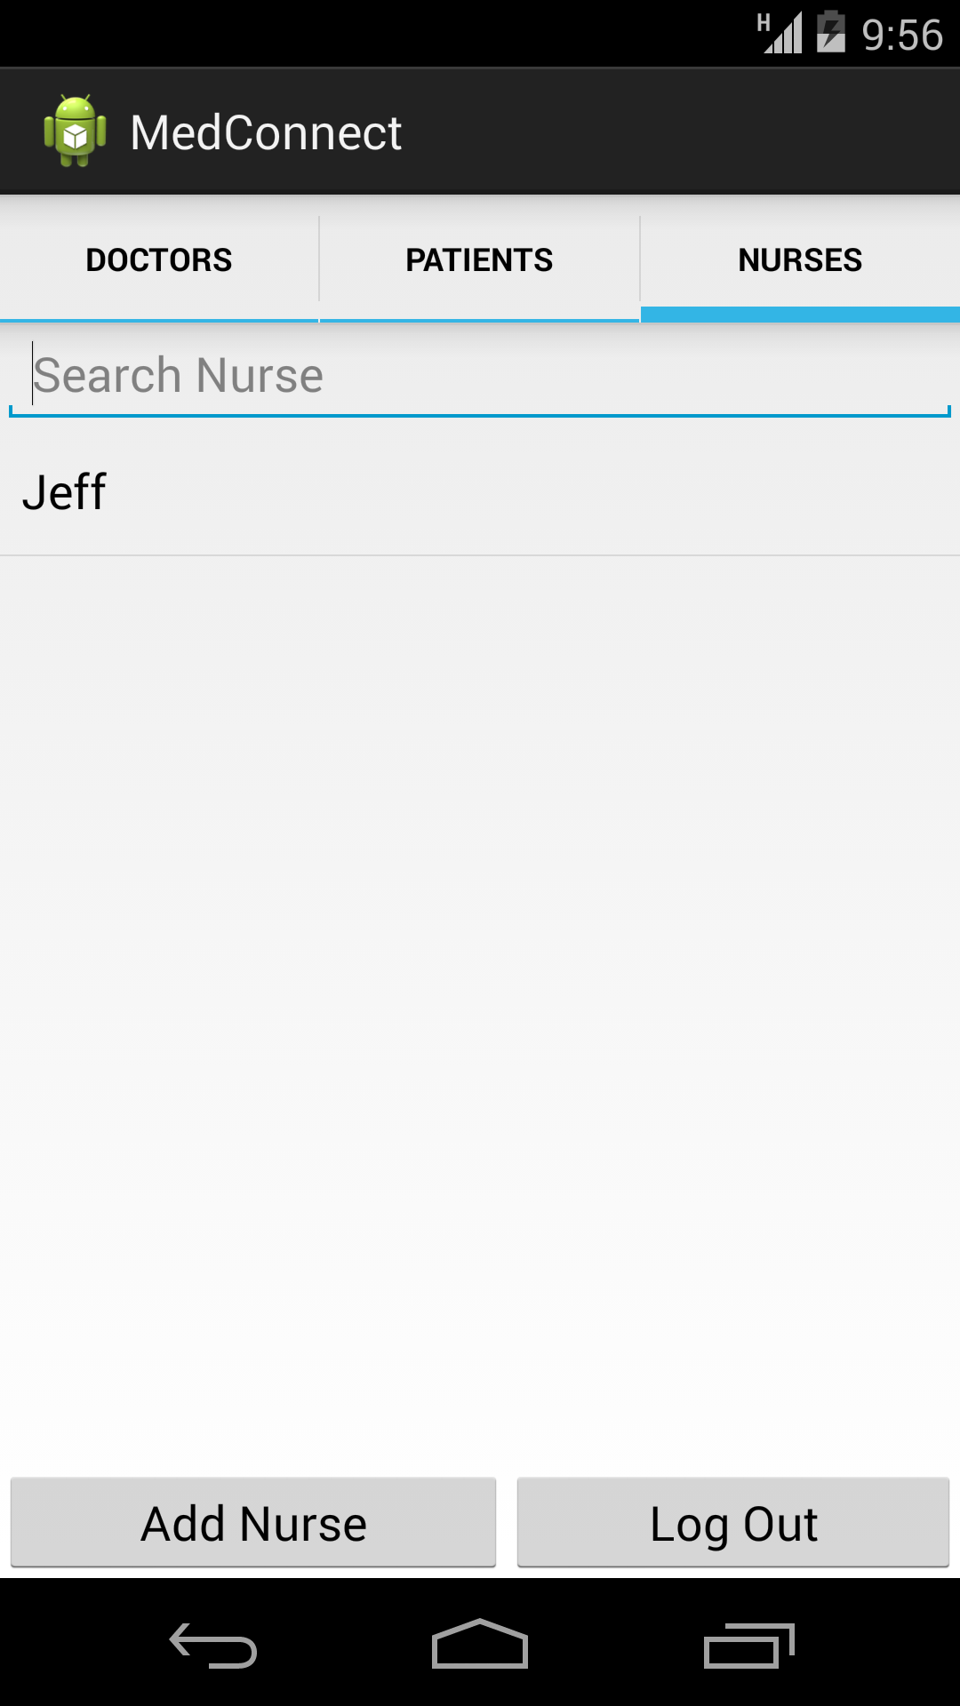

* 1. i) Attempt to create a new nurse user

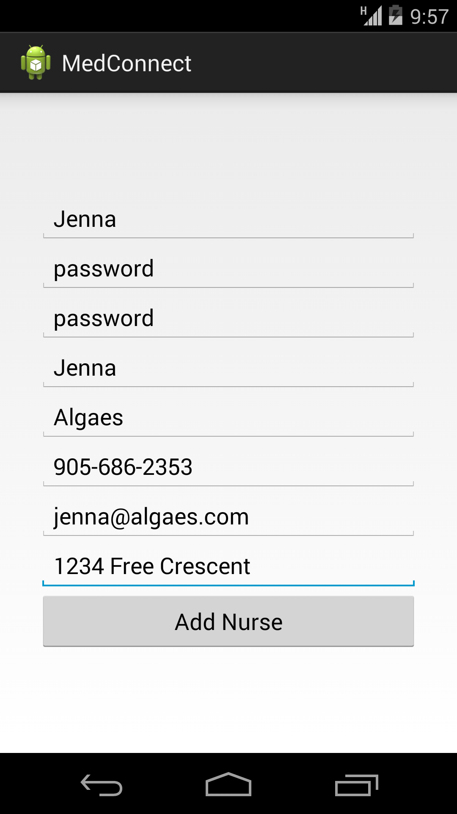

ii) Attempt to create new nurse user passed. New nurse user created.

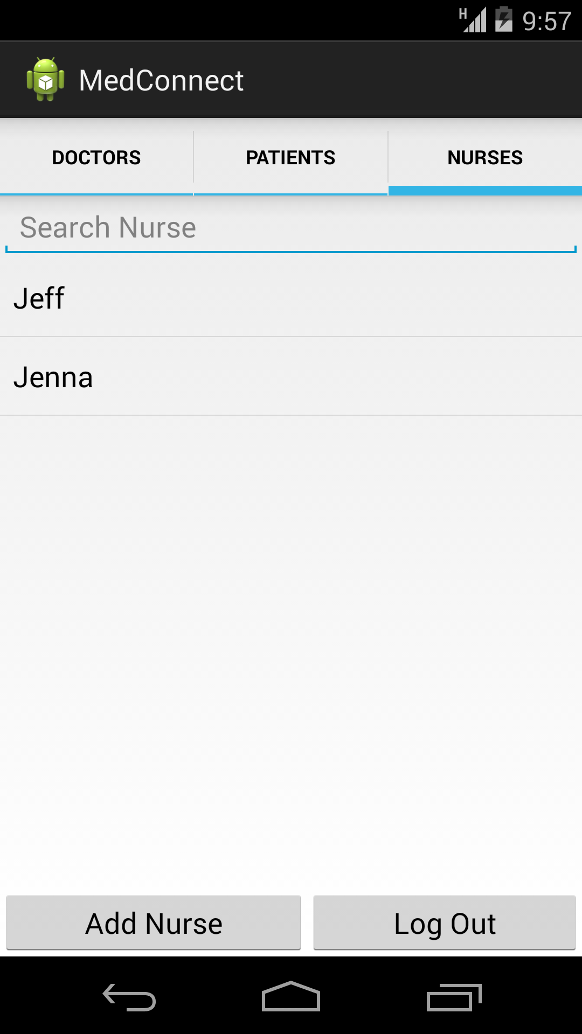

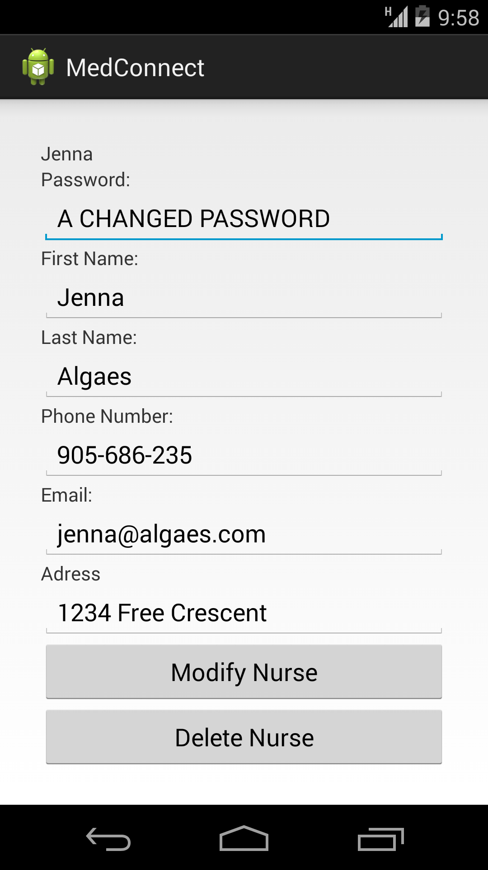

* 1. Navigate to patient tab
  2. i) Attempt to create a patient user

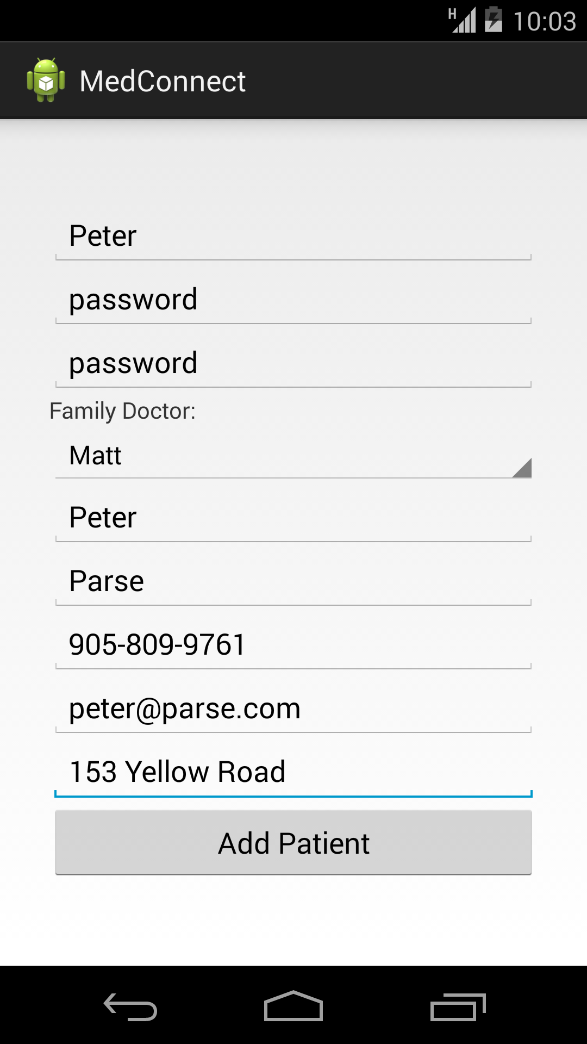

ii) Attempt to create new patient user passed. New patient user created.

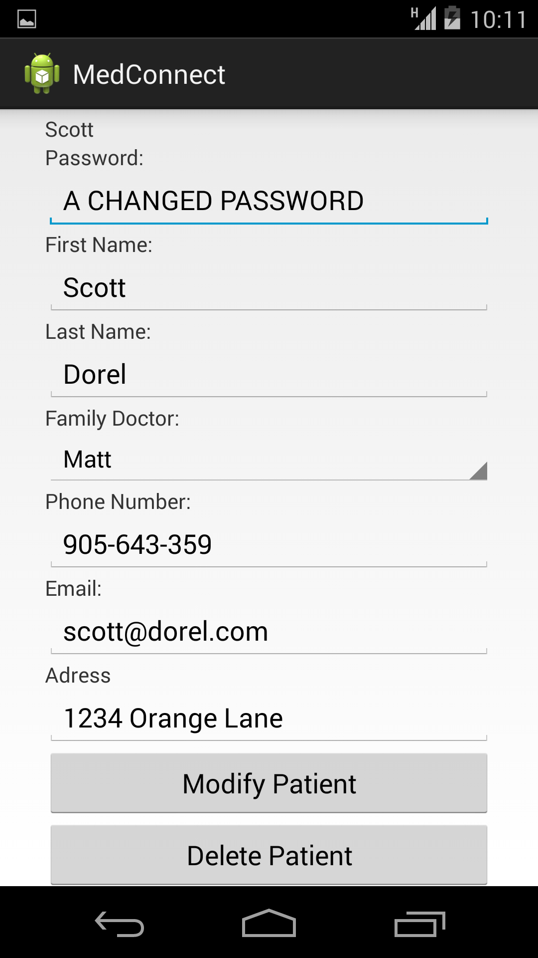

* 1. Log out of app

1. Log into app as a doctor



* 1. Click on and view a patient
     1. Add information to patient (choose patient)

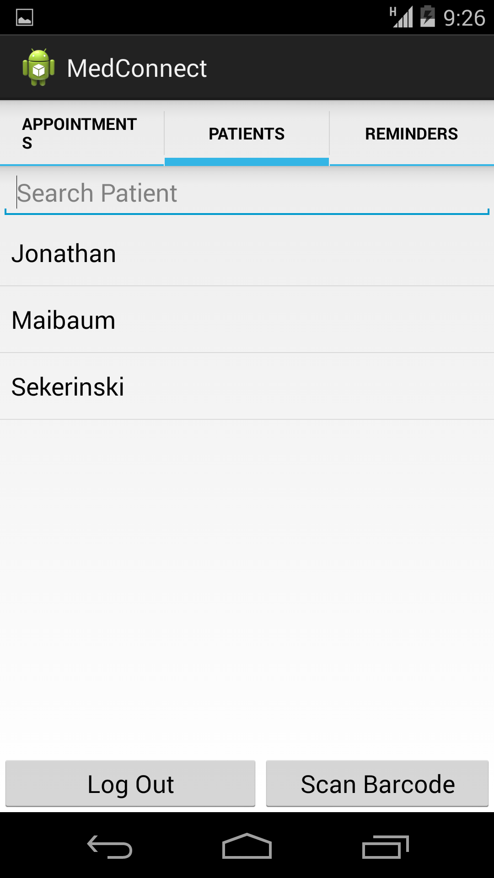

ii. Choose a patient

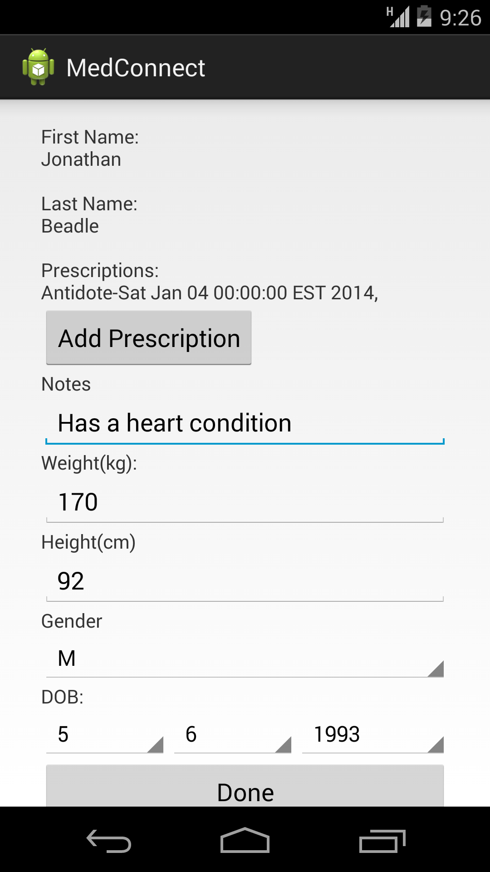

* + 1. Attempt to add a prescription to patient

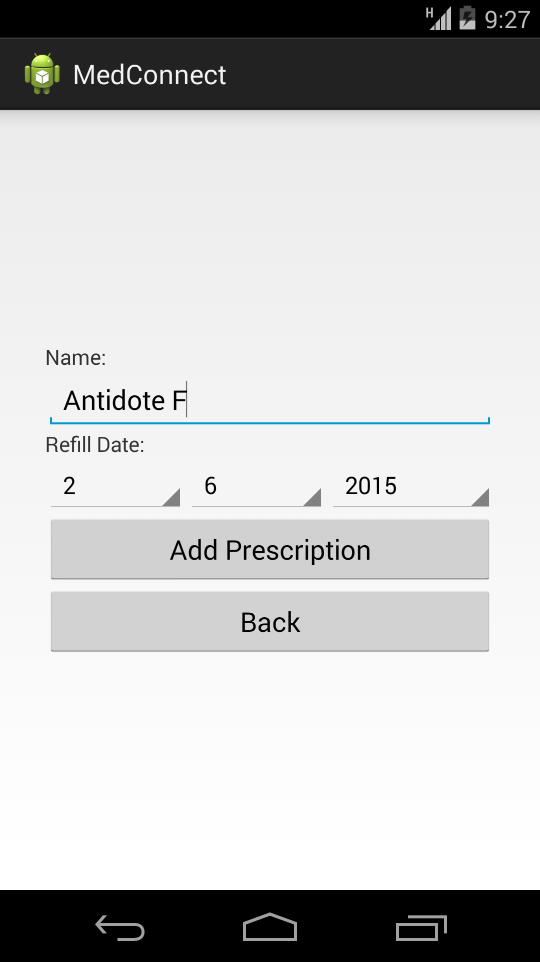

iii. Attempt to add a prescription passed. Prescription added to patient.

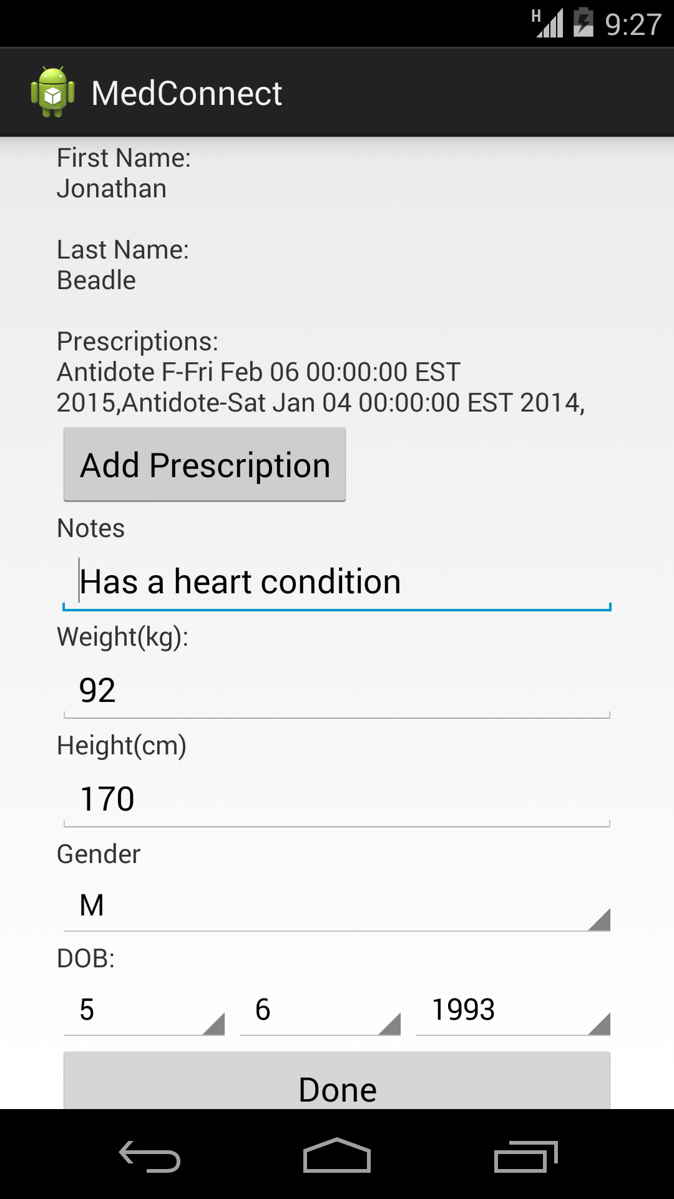

* 1. Navigate to patient graph and input a new BMI point

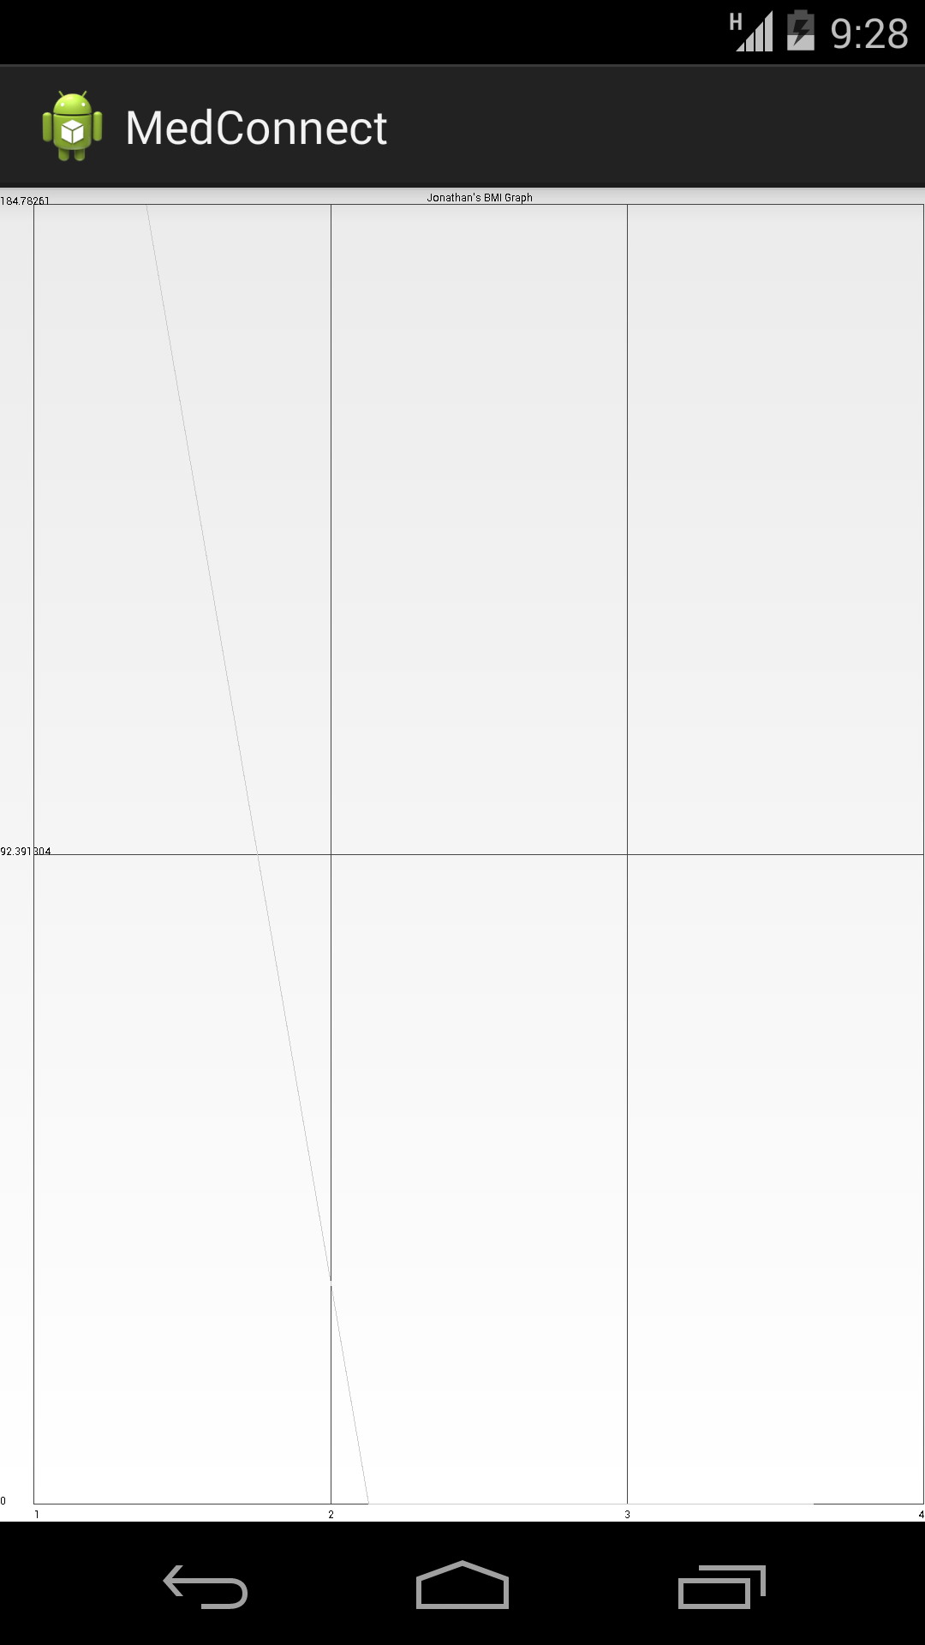

* 1. Navigate to reminders tab and view upcoming appointments

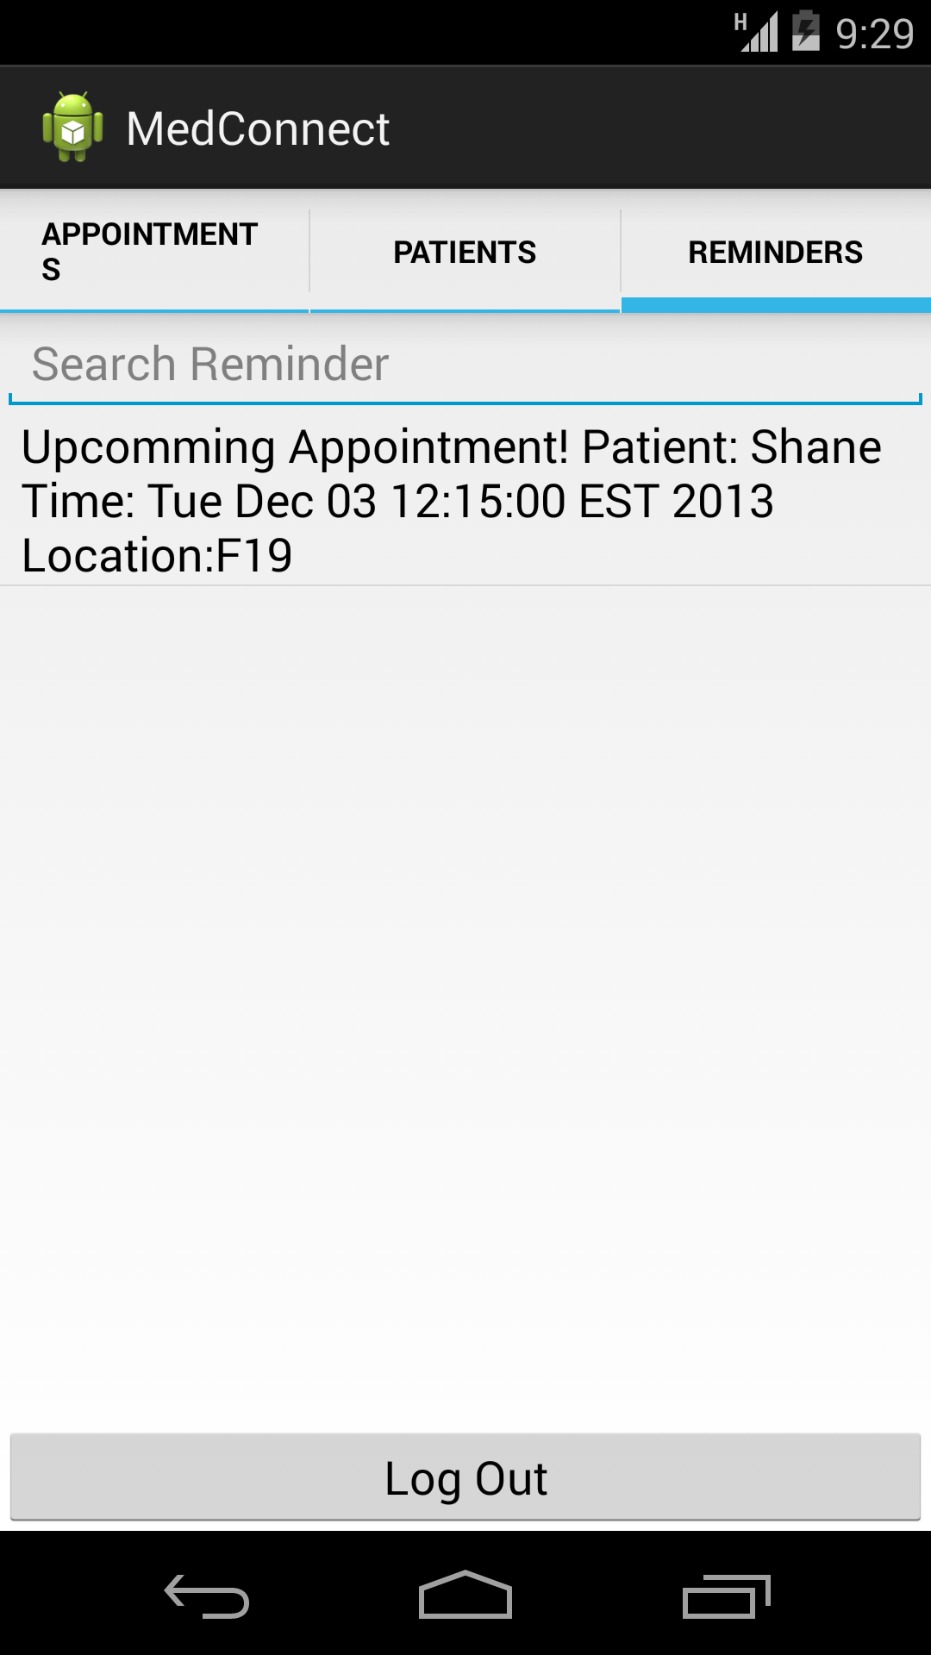

* 1. Log out of app

1. Log into app as a Nurse



* 1. View current appointments

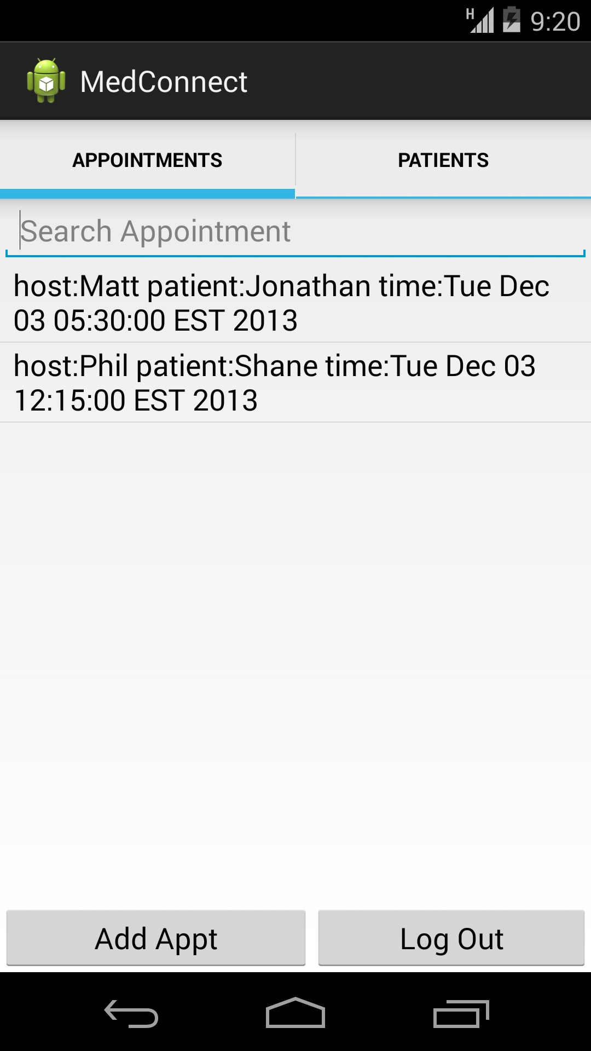

* 1. Attempt to add a new appointment

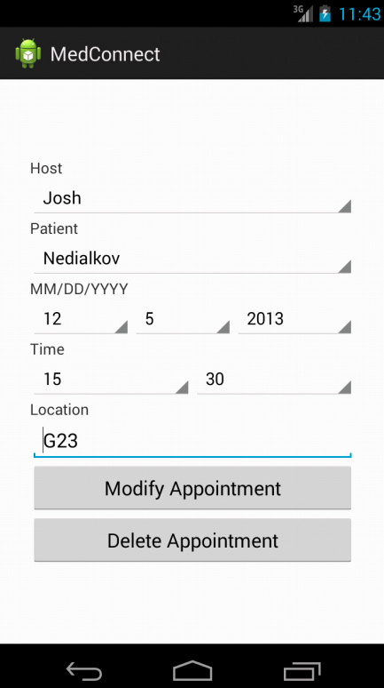

c. Attempt to create a new appointment passed. New appointment created.

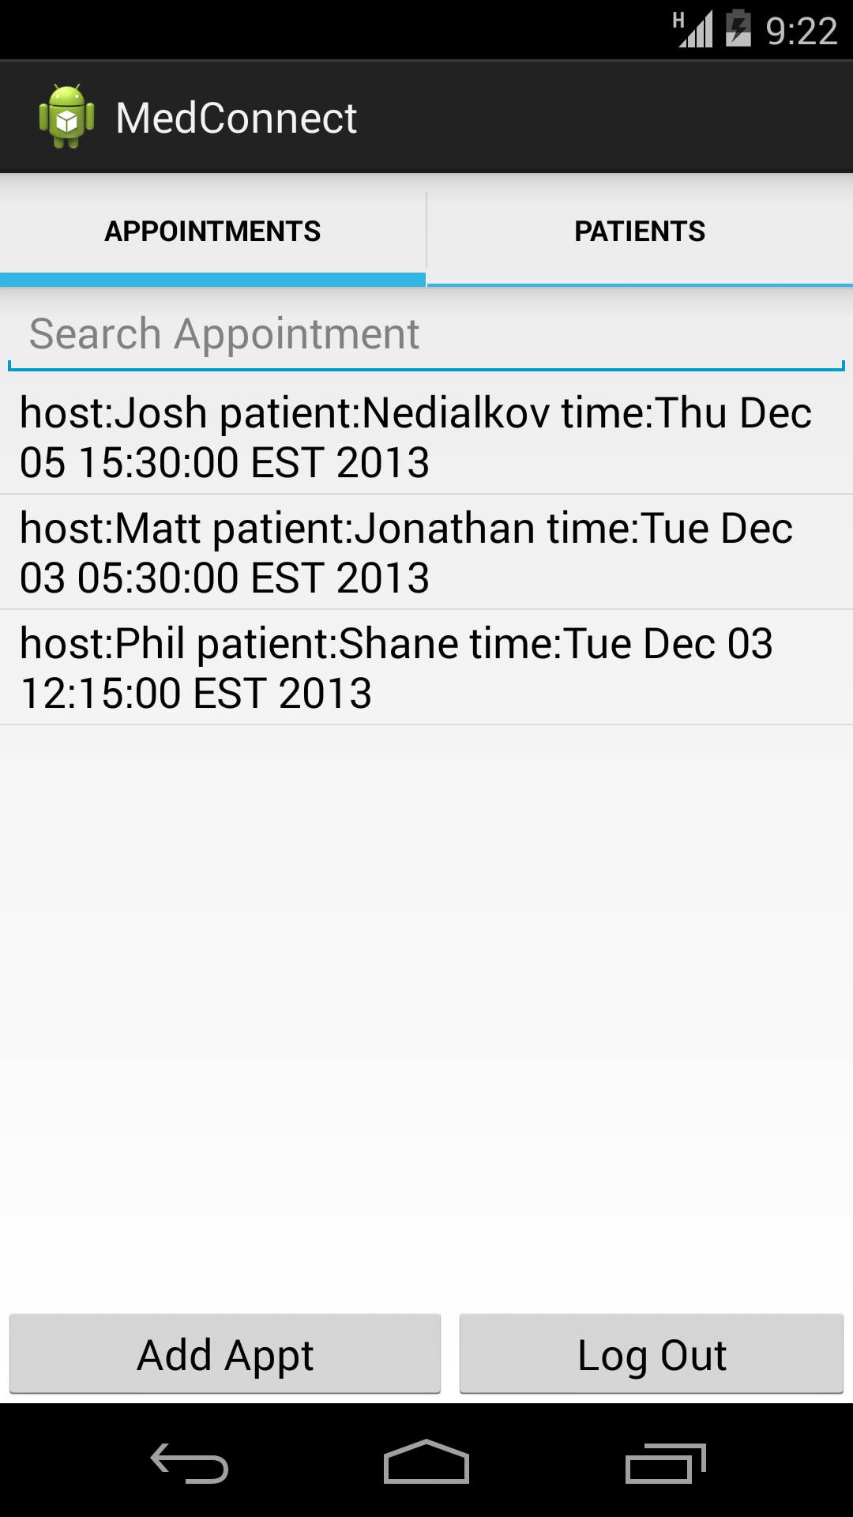

* 1. Navigate to patients tab

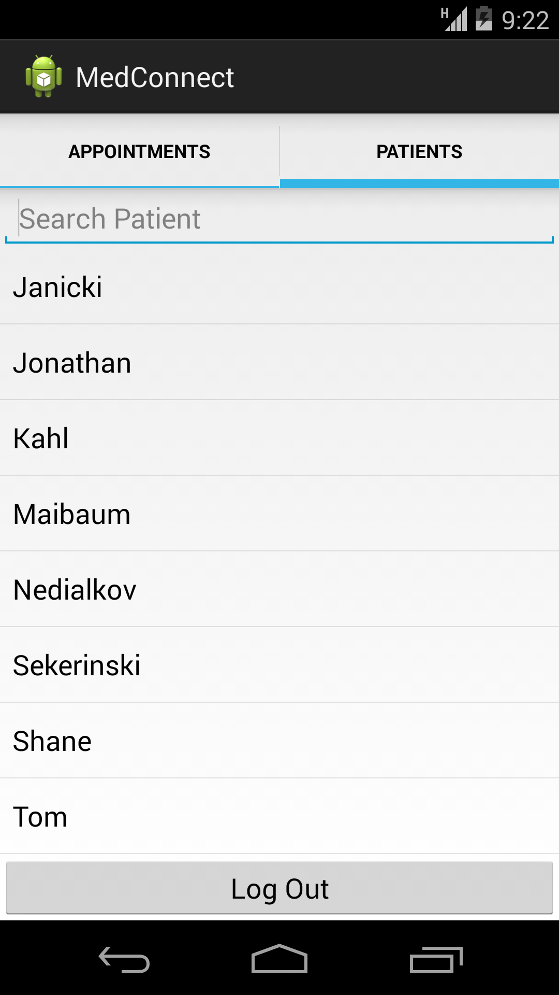

* + 1. View a patients information

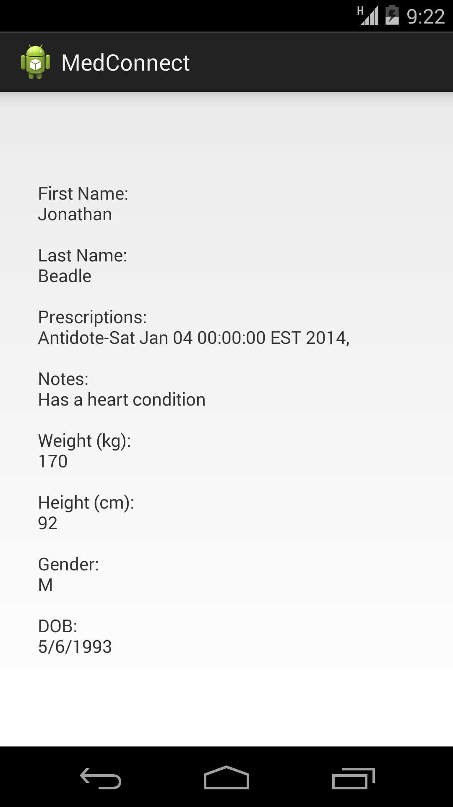

e. Log out of app

1. Log into app as a Patient



a) Navigate to appointments tab and view all current appoint 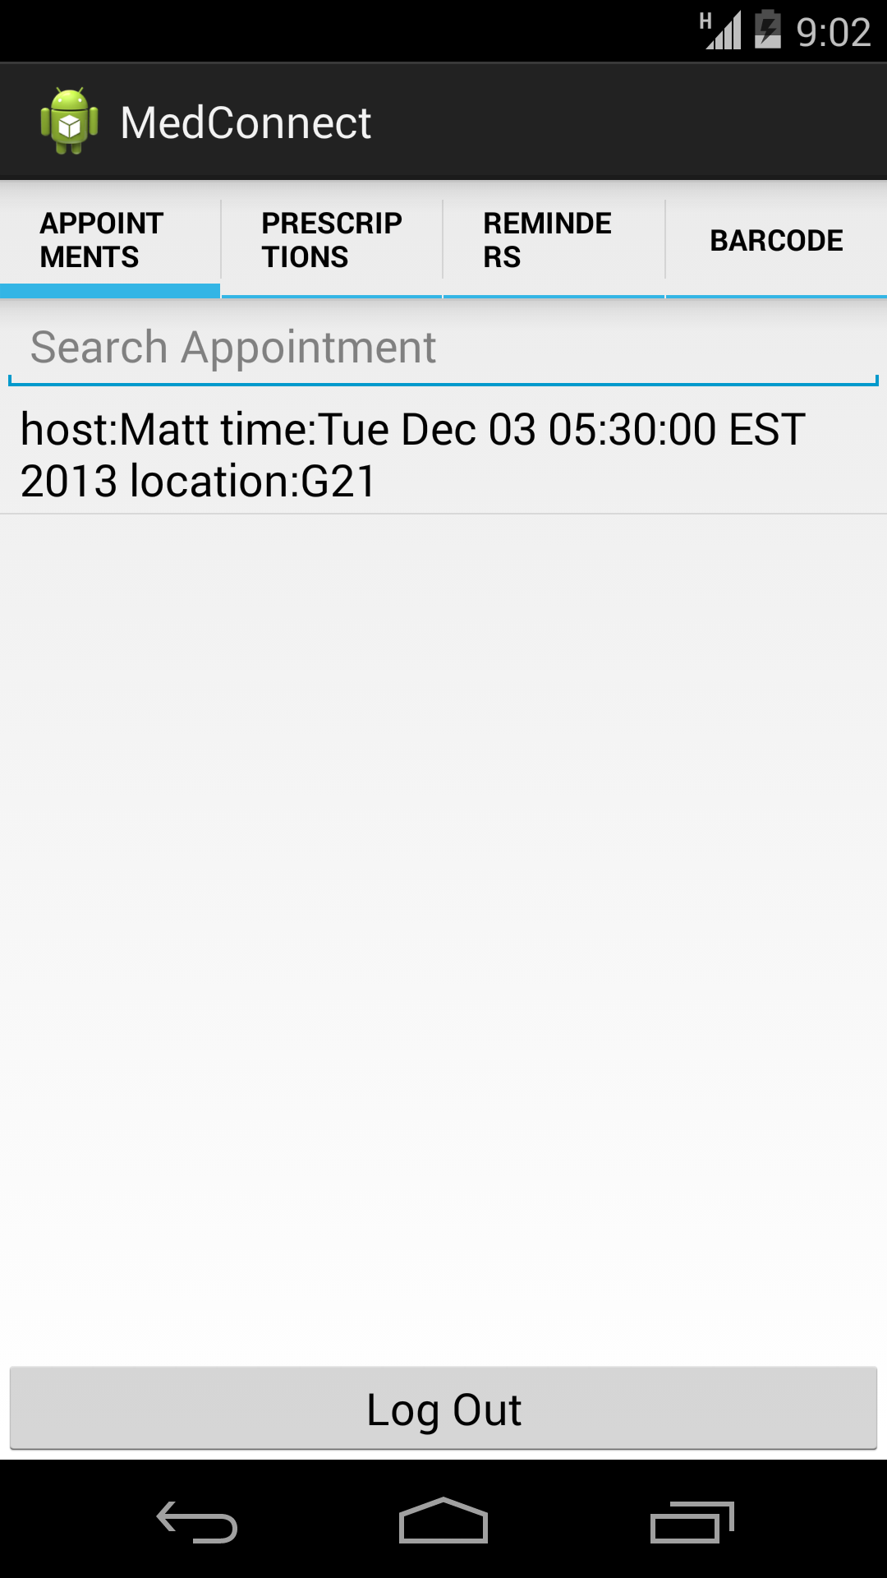

* 1. Navigate to prescription tab and view all current prescriptions 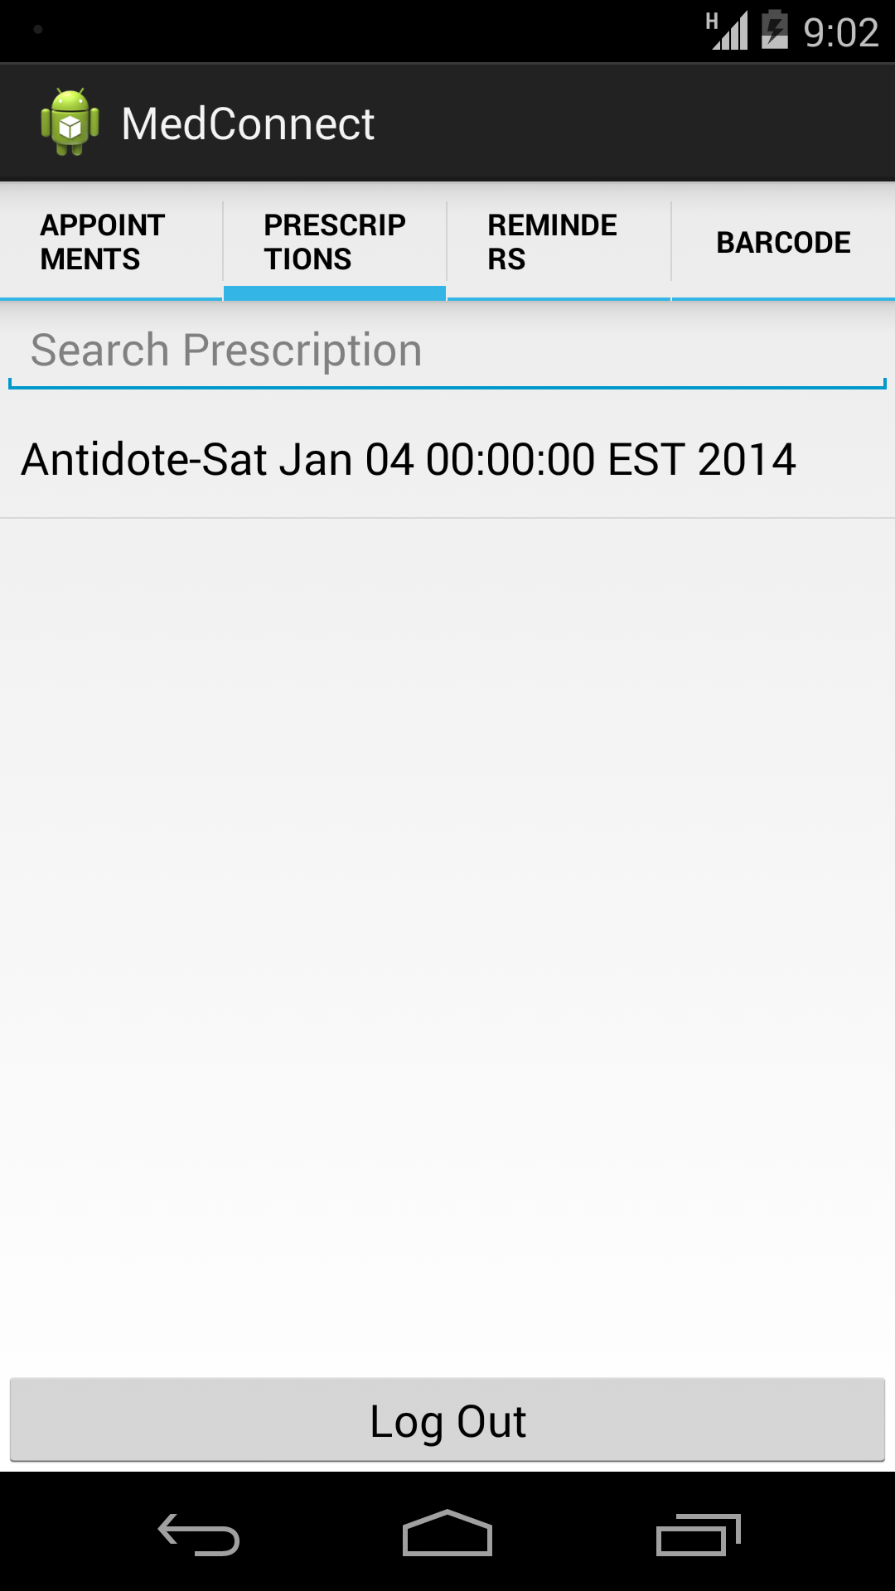
  2. Navigate to reminders tab and view all current reminders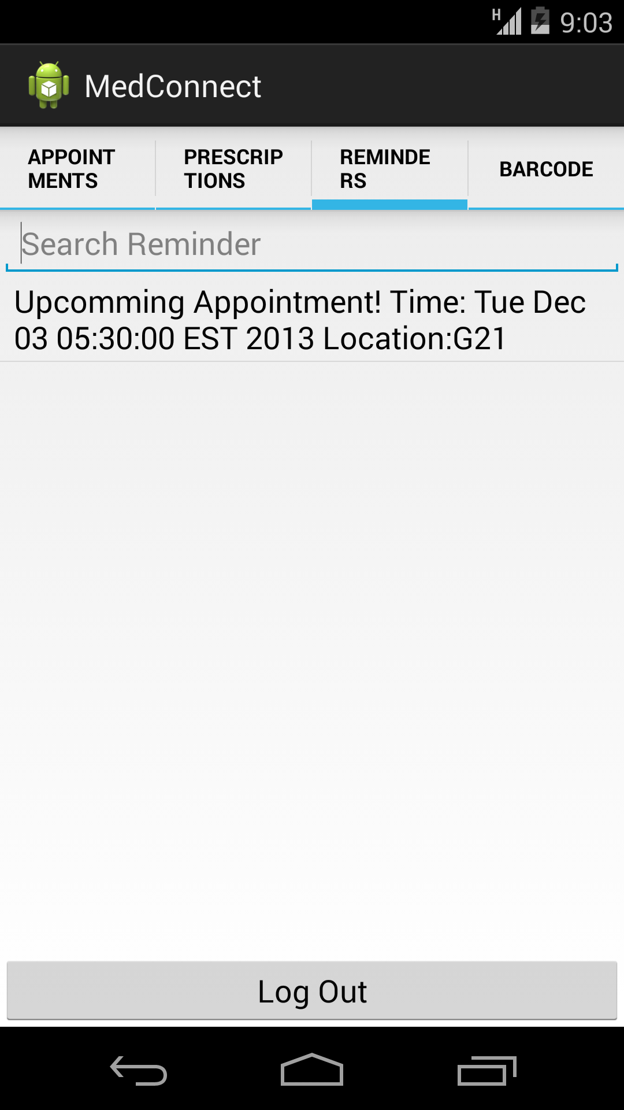
  3. Navigate to barcode tap

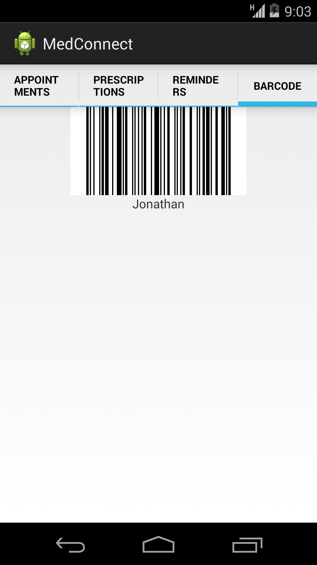

* 1. Log out of app

1. Log into app as a Nurse



* 1. Modify an appointment



* 1. Log out of app

1. Log into app as a Patient



* 1. View modified appointment



* 1. Log out of app

1. Log into app as an Admin



* 1. Modify a doctor and/or nurse (change password)

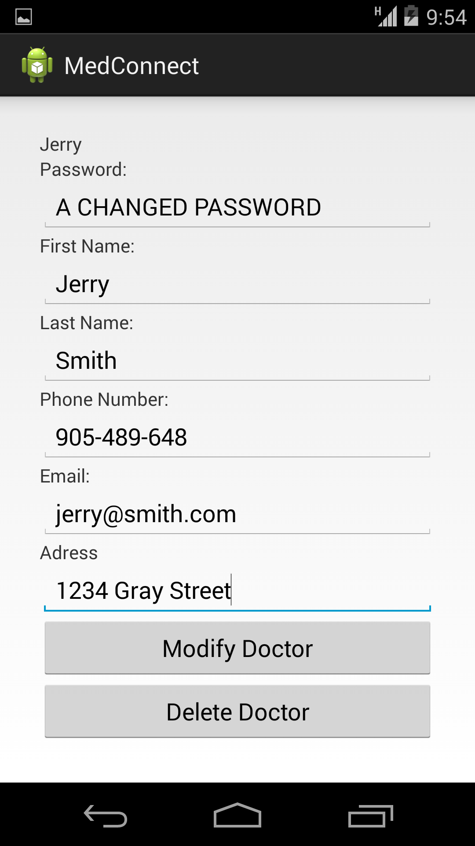



* 1. Log out of app

1. Log into app as a Doctor or Nurse (depending on which user was modified by Admin)(Attempt to login with a new password)



* 1. Log out of app.